# Pilot manuscript

Renata Diaz – July 17, 2020

## Introduction

[10,000 ft view/why dynamics/why change over time]

Classical approaches to studying ecological communities have focused on identifying stable or equilibrium states, rather than on the signatures of change over time. Recently, macroecology has begun to incorporate explicitly temporal perspectives – rather than employing time-averaging or assuming that a single observation period captures a stable or representative arrangement for a community. This is especially important now, given that over the past century, ecological communities have endured a period of unprecedented changes brought about via anthropogenic impacts. We set out in search of a more developed macroecological view of how community-scale properties change over time, and particularly whether they have changed directionally in recent decades.

[the state-variable, cross-community view]

We adopt a specifically macroecological perspective on community dynamics. We relinquish a focus on the rise and fall of individual species and instead use a set of aggregate characteristics, or “state variables”: the total number of individuals (*N*) and the total amounts of biomass (*M*) and/or energy use (*E*) present for a community at a moment in time. These state variables are directly comparable across communities comprising different sets of species or even representing different taxa or ecosystem types. While we sacrifice the details of which species are thriving and where, we gain the power to synthesize across numerous communities and identify prevailing trends in which kinds of dynamics tend to occur most frequently and in what general contexts. These three state variables capture related, but not identical, dimensions of community abundance, including direct measures of ecological function. Because they are *aggregate* variables, summed over the diversity of species and individuals that make up a community at any time point, they may be less variable and idiosyncratic than their component time series. While individual species maybe highly variable for countless reasons, shifts that propagate to the aggregate scale may be more reflective of consistent and systematic processes affecting the community.

[how things might change]

We have two centers-of-thought around how community-level abundance, defined generally, mightvary over time. Especially in theoretical exercises, *abundance* – variously measured in *N*, *E, M*, or even species richness – is often taken to be static or even as a hard constraint on species dynamics. This is, for example, one of the key elements of the classic formulation for neutral theory. In contrast, the weight of literature on the fate of ecosystems in the Anthropocene suggests that we are in an era of unprecedented biological loss, potentially across all currencies. Reports of declines in species richness, population sizes of individual intensively-studied species, and size-biased declines in large-bodied taxa all point towards the expectation of systematic declines in abundance. There are at least two additional, less popular and more complicated, general types of dynamics we might observe. First, communities might pass through multiple regimes or eras where one type of dynamics – no change, or systematic directional change – are dominant, only to be replaced by another trend in a later time period. The net effect could be overall trends, or in a time series that appears not to change *overall* despite considerable, nonrandom, variability. Second, the trajectory could be highly variable – not static – but without detectable temporal structure, even with the option of breaking into disjoint regimes.

[but we don’t know about the **community** scale]

Despite these assumptions and expectations, we do not have a well-resolved empirical picture of how abundance changes at the community scale. The community-scale question differs somewhat from theoretical conventions and population-level assessments. The theoretical assumption of fixed abundance is a mathematical convenience, not an assertion about reality. The trajectories of individual populations do not necessarily reflect the overall aggregate trajectory; even if *most* species in a community have an overall positive slope to their populations, if the few most abundant species are declining, the overall signal will be of decline. Because changing species composition can result in shifts in the average body size of a community, the trajectory of the number of individuals also does not necessarily track the trajectory of total energy use or total biomass. For example, body-size shifts may cause an apparent lack of change or even increase in the number of individuals to mask declines in overall energy use, if small species are becoming more abundant while large species disappear.

[why we don’t know about communities: data]

Documenting the dynamics of community-level abundance in these three currencies requires a type and amount of data that is challenging to collect, especially for terrestrial animals, and therefore rare. Community-wide population censuses, conducted consistently over time, are rare enough for terrestrial animals. Of those that exist, it would usually be impractical to also collect highly detailed size data for the full range of species observed (with the notable exception of small mammal communities). Recently, the combination of large databases of ecological timeseries and trait data, and greatly expanded computational capacity, have made it possible for us to fill in this gap and generate realistic estimates for timeseries of *N*, *E*, and *M* for large numbers of ecological communities.

[capturing (some degree of) nuance in dynamics]

Given newly available data streams, we have the opportunity to for the first time document community-level state variable trajectories for the three currencies. We set out to distinguish among broad classes of dynamics for the state variables, and document which types of dynamics occur most commonly among the communities in our database. We also set out to test whether different kinds of dynamics are more typical for the different currencies.

We define four classes of dynamics that might reflect qualitatively different histories for a community. First, a time series may be best-described by a simple linear model with little to no slope. This can reflect a fairly static trajectory over time, especially if the variation around the mean is low across the time series. It may also signal highly variable fluctuations with respect to time verging on noise. Second, it may be well-described via either a single slope, or as multiple eras with varying slopes that accelerate or decelerate but maintain a monotonic trend, resulting in a net increase or decline over the observation period. Either of these variations points to a systematic change in abundance over time. While these first two classes feature consistent dynamics across the course of the time series, it is also possible that the observation period encompasses multiple segments with contrasting trends. These differ from random fluctuations, in that the trendswithin segments are internally consistent, and detectably different from the trends in adjacent segments. In these cases, the best *linear* description of the time series is an oversimplification that can mask or distort complex, systematic dynamics. The third class of dynamics describes multi-segment time series with at least one change in direction, but resulting in no net change in abundance from beginning to end. While the average, and often the best-fit linear, slope for these time series may be near zero, conflating them with either static or essentially noisy dynamics (as in the first class) would elide multiple periods of systematic change that happen to cancel each other out over the observation period. The final class is for multi-segment time series that change direction but maintain a net increase or decline over the study period. This is a more complex scenario than a monotonic trend (even one that accelerates or decelerates). The net change that results from a non-monotonic trajectory is perhaps weaker evidence of a directional shift than change that is more consistent over time.

[implications of which classes dominate abundance generally]

Which of these classes dominate community abundance timeseries has implications for how we understand biodiversity trends in the Anthropocene, and for how we approach analyzing these time series in greater detail. If the majority of time series are well-described via simple linear, or monotonic, trends, we may be able to proceed with the relatively straightforward interpretation that the distribution of slopes for these trends reflects the prevailing trends, and that these trends are relatively likely to hold for the immediate future. If most of these slopes are concentrated around zero, we may be witnessing relatively little change in abundance at the *community* scale despite considerable evidence of change to individual species and populations – perhaps because communities are buffered, in aggregate, against the fluctuations of their component parts. If we find large contingents of positive or negative slopes, these may signal systematic trends in abundance over the past half-century. Especially if we were to find mostly negativeslopes, it would signal systematic declines in abundance that echo alarm calls about defaunation. However, if many or most community abundance timeseries are better described via multiple segments with changes in direction, we may need additional analytical tools to disentangle systematic, but complex, *trends* from complex, trend-agnostic dynamics. The net or average change for these timeseries may reflect genuine trends or patterned dynamics on longer timescales, but may not be an adequate summary of the most important underlying dynamics or a reliable indicator for future dynamics.

[implications of different classes for different currencies]

Energy != nind

Energy may be more buffered than nind

Energy may more directly reflect function than nind

If energy == nind……. Interesting?

## Methods

### Data

We analyzed energy and total-individuals timeseries for 108 communities from the North American Breeding Bird Survey (). Because this is a preliminary analysis, we used the first 100 that come up alphabetically by the “rt_rg” designation as implemented via MATSS, and an additional 8 communities selected because of personal significance. They are not at all random spatially and are probably not representative of the dynamics in the database as a whole.

We constructed the total-individuals timeseries as the total number of individuals observed for each year sampled. We constructed the energy timeseries via estimations based on scaling relationships (metabolic theory, Thibault). First, following Thibault et al (2011), we estimated the body size for every individual observed, based on species’ mean and standard deviation body size documented in Dunning (2007). For species with no recorded standard deviation, we estimated the standard deviation based on the scaling relationship between species’ mean and standard deviation body size documented in Thibault et al (2011). We then estimated individual’s metabolic rates via metabolic scaling (), and summed the metabolic rates of all individuals observed at each time point to obtain the total energy use at that time point.

### Categorizing dynamics

For every time series of a community’s energy use or total number of individuals, we summarized the dynamics using a combination of segmented linear regression (also known as breakpoint regression, piecewise linear regression, broken-stick regression, and others) and simple linear regression.

We fit simple linear regression models with only the intercept (i.e. no slope) and with slope and intercept terms, and segmented linear regression models with intercept-only and with slope and intercept terms. We allowed the segmented regressions to be discontinuous, such that the model prediction for the first observation in one segment need not be continuous with the last observation in the preceding segment. This allows fits to faithfully describe sudden jumps and step functions, which occur in these time series. We did not specify the number of segments *a priori* but did constrain them such that every segment must contain a minimum of 4 observations (approximately 10-20% of the observations in most of our timeseries). We implemented segmented regression models using the *strucchange* package for R, and OLS models using the base R lm() function. We then selected the best-fitting model – segmented or not, slope or not – using BIC. It may be more appropriate to use a crossvalidation or training/test split, and to develop some way to describe whether multiple models fit similarly-well. We did not make any effort to detect or account for autocorrelation or non-normality in the data.

We used the fitted values derived from the best-fitting model to determine whether a timeseries’ dynamics were best described as monotonic or changing direction. If all of the timestep-to-timestep differences in the fitted values were of the same sign, or 0, we designated the timeseries as monotonic; if there were both positive and negative differences in the same timeseries, we designated it as changing direction. All one-segment (OLS) models describe monotonic dynamics. Multi-segment models may be monotonic or changing direction.

We tried several approaches to detect and measure the net trend in a timeseries. First, we fit a one-segment linear model and tested whether the slope term was statistically significant. For one-segment models, this is equivalent to the best-fitting model; for multi-segment models, the strictly-linear fit can elide considerable variation. We describe the overall change as the ratio of the model prediction for the last observation to the prediction for the first observation. If the slope is 0, this ratio is 1. Second, we compared the value observed for the first five observations to the last five observations. We tested for significant differences using t-tests and Wilcoxon tests. We described the overall change as the ratio of the mean of the last five to the mean of the first five. This approach is less susceptible than the one-segment linear model to missing a trend due to highly nonlinear dynamics in the middle of the timeseries, but it is highly sensitive to the choice of the number of observations to include (in this case, 5 was chosen because it accounts for approximately 1/4-1/8 of the observations most timeseries).

For timeseries that were best described via a one-segment linear model with no slope term, we calculated the coefficient of variation to help describe whether that timeseries hews closely to its mean or fluctuates widely over time.

### Summarizing dominant dynamics

We tallied the number of timeseries falling into the following categories:

* Monotonic without a statistically significant net change
* Monotonic with a statistically significant net change
* Changing direction without a significant net change
* Changing direction with a significant net change

We report the distribution of net change (described as the ratio of the end:beginning of the time series) broken out according to monotonic and changing-direction. For timeseries without a statistically significant net change, this ratio is reported as 1.

We report results using both of our approaches to detecting and describing net change.

For timeseries that were best-described as monotonic without a statistically significant net change, we also report the coefficient of variation to describe the variability around the mean over the course of the observation period.

## Results

#### Change via linear model and BIC

|  |  |  |  |  |  |  |
| --- | --- | --- | --- | --- | --- | --- |
| Currency | Change (all) | Monotonic trend | Turns and trend | No trend (all) | Monotonic no trend | Turns and no trend |
| Abundance | 58 total  40 decrease  18 increase | 23 total  16 decrease  7 increase | 35 total  11 increase  24 decrease | 50 total | 20 total  6 steps  14 flat | 30 total |
| Energy | 49 total  25 decrease  24 increase | 23 total  10 decrease  13 increase | 26 total  15 decrease  11 increase | 59 total | 24 total  2 steps  22 flat | 35 total |

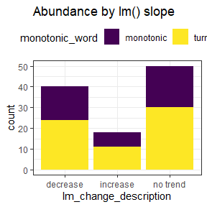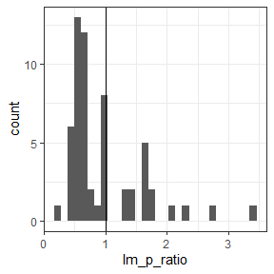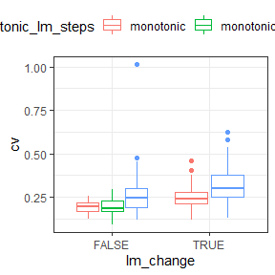

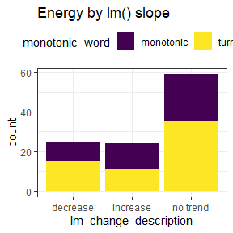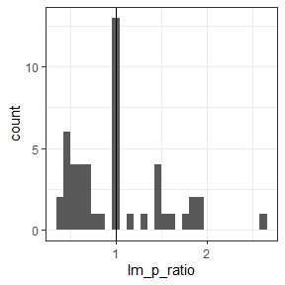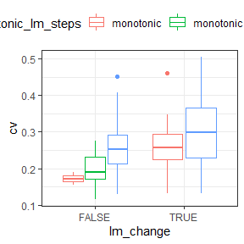

#### Change via beginning-end comparison

|  |  |  |  |  |  |  |
| --- | --- | --- | --- | --- | --- | --- |
| Currency | Change (all) | Monotonic trend | Turns and trend | No trend (all) | Monotonic no trend | Turns and no trend |
| Abundance | 43 total  28 decrease  15 increase | 16 total  12 decrease  4 increase | 27 total  16 increase  11 decrease | 65 total | 38 total | 27 total |
| Energy | 28 total  17 decrease  11 increase | 15 total  8 decrease  7 increase | 13 total  9 decrease  4 increase | 80 total | 32 total | 48 total |

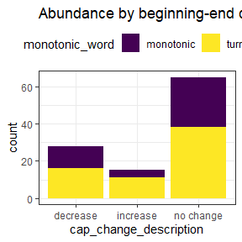

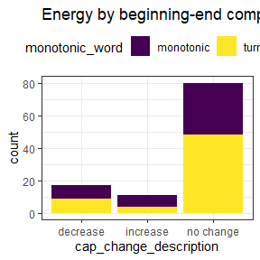

For abundance, roughly 50% of sites had either no slope for a strictly linear fit (50/108) or no significant change from beginning to end (65/108). Of those that did exhibit a slope or a change from beginning to end, roughly 2/3 were decreasing while 1/3 increased.

65 (of 108) sites were better-described via multi-segment regression models that included changes in direction than via strictly linear models or multi-segment models with an overall monotonic fit. These sites accounted for approximately 60% of sites in each category (exhibiting no slope, increasing, and decreasing trends) when fit with a strictly linear model.

Of the 50 sites whose best-fit linear model had no slope term, only 14 were best-fit by a linear model with 0 slope (as opposed to multi-segment models).

For energy, even more sites exhibited either no slope with a linear fit (59/108) or no significant change from beginning to end (80/108). Nonzero slopes were evenly split between increases and decreases, while 60% of beginning-to-end changes were declines. 61 (of 108) sites were better-described with changes in direction than via monotonic fits. Of the 59 sites whose best-fit linear model had no slope, 22 were best-fit by a 0-slope linear model when multi-segment models were included as candidates.

Testing for significant differences between the beginning and end of the timeseries consistently identified fewer significant changes than the linear model fit.

## Discussion

[on overall trends]

* For half (or more) sites, we do not detect overall significant trends or change. When we do detect change, decreases in *total individuals* are twice as common as increases. Declines and increases are more evenly balanced for total energy.

[on more complex dynamics]

* A majority of sites are better-described with changes in direction than via monotonic fits
* These changes in direction can include different types of more complex dynamics that are not well-captured via a linear fit and may cause the linear trajectory to be misleading
  + Cyclical dynamics, distinct regimes, or idiosyncratic changes
  + The linear trajectory that splits the difference between distinct regimes does not necessarily reflect either regime accurately, and is not necessarily a strong predictor of future dynamics
  + Similarly, a linear trajectory fit to something cyclical can be strongly dependent on where in the cycle we begin and end our observations, and will not necessarily be a strong indicator of future trends
  + Even when the linear fit finds a slope of 0, there can be *considerable*, often temporally structured, change over the course of the timeseries
* Methods than can detect and describe more complex temporal structures may be appropriate for summarizing these timeseries. One challenge will be synthesizing across the diversity of dynamics that can occur.
* The high prevalence of complex dynamics indicates that whatever drives abundance trajectories in these communities, it has not been a consistent, relentless march to extinction.
* However, declines are more common than increases for both complex and monotonic timeseries. If this holds at scale, it suggests that the net direction of change has generally been negative over the past 40 years…

[on static, vs non-temporally-structured, timeseries]

It is important to distinguish between the absence of a detectable linear slope and a signal of static dynamics. Most sites, even those whose best linear fit has no slope, feature multiple periods of statistically detectable change. These sites are hardly static; it is just that the net effect is not a simple linear trend. However, 14 sites were best-fit via a one-segment model with no slope term. These sites have the *most* potential to be static, or unchanging, over time.

[on energy compared to abundance]

By any measure, we detected changes in total energy use less frequently than we did for abundance. When we did detect changes, they were more evenly split between increases and decreases.